Setting up WinFluor with the Prairie Ultima system

Installations

- Install WinFluor V2.4.6.
- Install Axon Multiclamp 700B panel software (if not already installed).

BNC 2090 Panel settings

WinFluor A/D inputs and D/A outputs are via the PCI 6052E card connected to BNC 2090 panel B in the Ultima 19”`rack. Note Panel B is the BNC 2090 panel which does not have the PMTs connected to it.

- Set the DIFF/SE switches on Panel B to SE and the NRSE/RSE switch to NRSE.
- Connect PFI0 on Panel B to PFI0 on Panel A (this connection may already be in place).

MultiClamp 700B Connections

Connect the following cables between the MultiClamp 700B and the BNC 2090 Panel B.

MultiClamp 700B | BNC 2090 Panel B (PCI 6052E card)
Channel 1, Primary O/P | ACH0
Channel 1, Secondary O/P | ACH1
Channel 1, Command I/P | DACOUT 0

Note. The Multiclamp 700B USB cable should also be connected to a computer USB port.

Starting up the programs

- Start MultiClamp 700B control panel
- Start PrairieView
- Start WinFluor

Note. WinFluor must always be the last program started.

Configuring WinFluor

- Select Load Settings from the WinFluor Setup menu and select Ultima Settings.cfg.
- Stop and re-start WinFluor.

The WinFluor Camera Setup dialog box should be as follows (except that Device 1 should be a PCI 6052E not a DAQ-card 1200)..

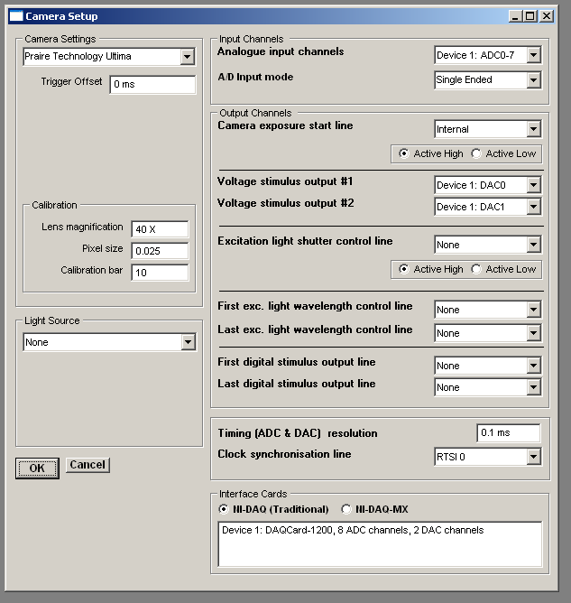

Note. If Device 1 is not the PCI 6052E card, you may need to change the Analogue Input and Voltage Stimulus Output settings to the actual PCI 6052E device number.
Initial Check

- Attach model cell to patch clamp headstage
- Select Seal Test/Monitor from the WinFluor Record menu.
- The seal test pulse should be displayed.

Acquiring a line scan

- Acquire an image using Prairie-View
- Click the LS button on the Prairie-View Image window.
- Enter the number of lines to acquire in the Line Scan window.
- Select Live Images from the Record menu (WinFluor).
- Enter a recording time longer than the line scan duration (WinFluor).
- Select a stimulus protocol (WinFluor).
- Click Start Scan button in the Prairie-View line scan window.
- The line scan and patch clamp recording should appear in WinFluor.

